**System Configuration Manual**

Welcome to

**Punjab and Sind Bank**

**E-procurement**

[**https://Psb.eproc.in**](https://Psb.eproc.in)

# Pre-Requisites before Logging in

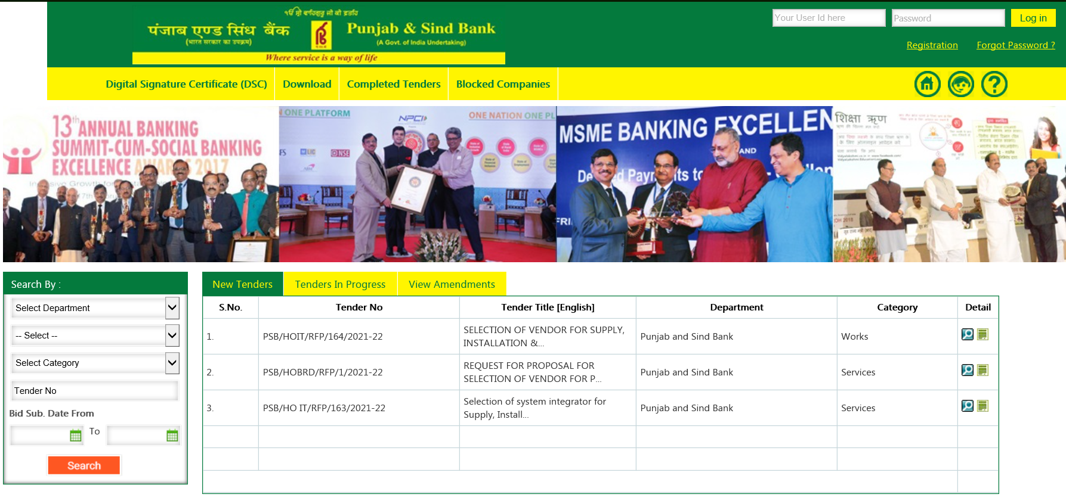

1. Minimum of 512 MB of RAM.
2. Minimum 1 USB port (If Digital Signature Certificates in USB-Token)
3. Windows 7 and above Operating System
4. Digital Signature Certificates
   1. Only Class-III Digital signature is required
   2. DSC Dongle driver should be installed before logging in
   3. DSC should contain both Signing and Encryption Certificates
   4. Reliable Internet Connectivity.
   5. Certificate with full chain.
5. Internet Explorer Versions 11
6. Java Run Time Environment 8 update 25 (32 Bit) Java 8 update 77 (32Bit)

Please make sure you fulfill all these Pre-Requisites.

# Setting for Internet Explorer

Browser Settings: Some browser settings are required for successful login and other process to occur on the system. Also to set the browser so that the required file “C1Sign.jar” can be downloaded and installed by the system itself. Run the application on Compatibility mode.

For Browser Setting the steps are following:

1. Go to internet options

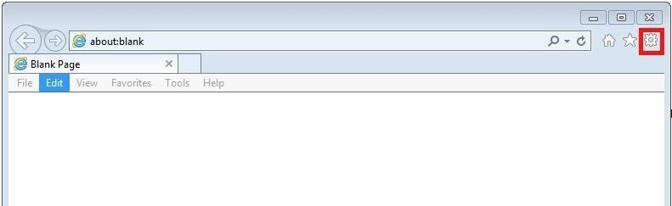

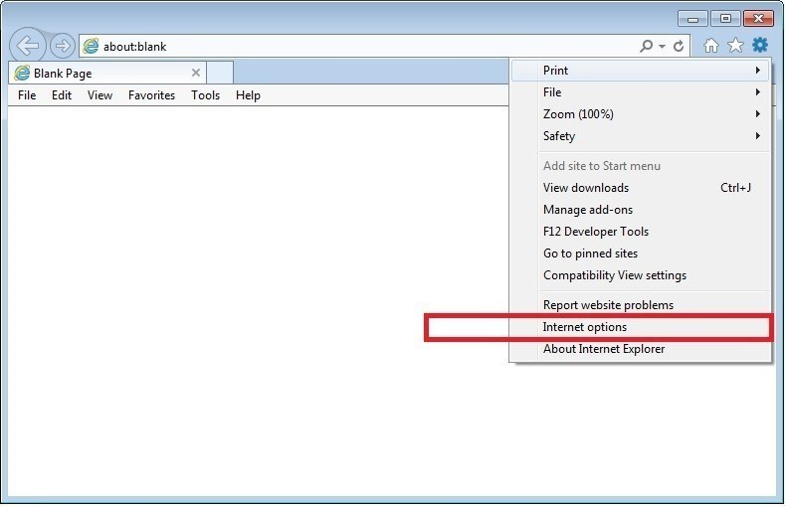

1. Go to Security Tab of Internet Options.

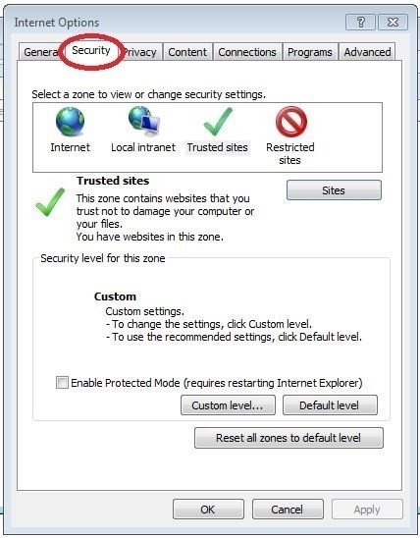

1. Select Trusted Sites Zone.
2. Click on Sites button and add https://psb.eproc.in.

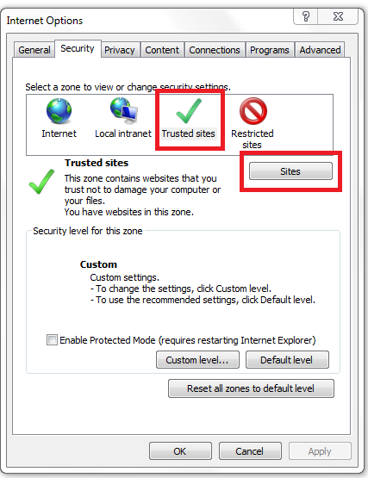

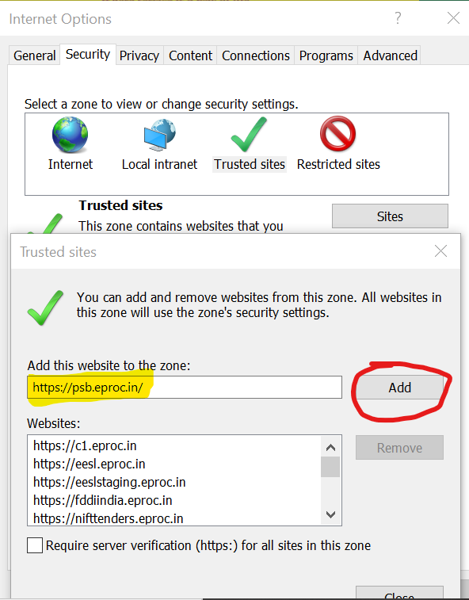

1. After adding https://psb.eproc.in Clos e this Trusted Site Tab.
2. Now Click on Custom Level to access Security Setting - Trusted Site Zone.

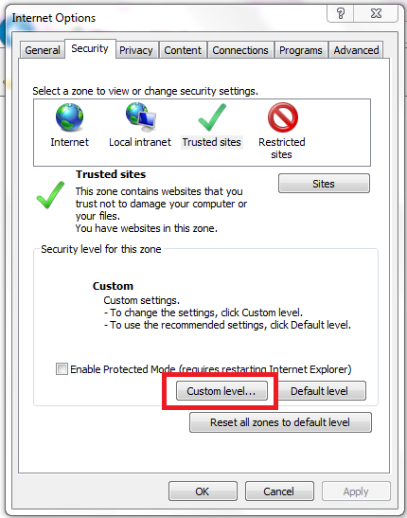

1. In trusted sites zone setting make following changes:
   1. Allow ActiveX Filtering : Disable
   2. Allow previously unused ActiveX controls to run without..... : Enable
   3. Allow Scriptlets : Enable

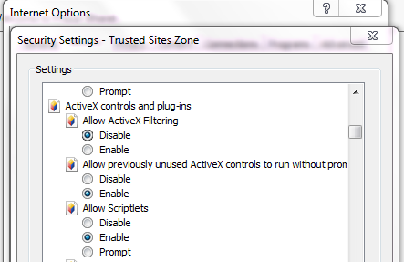

* 1. Automatic Prompting for ActiveX controls : Enable
  2. Binary and script behavior : Enable
  3. display video and animation on ... : Enable
  4. Download signed ActiveX controls : Enable

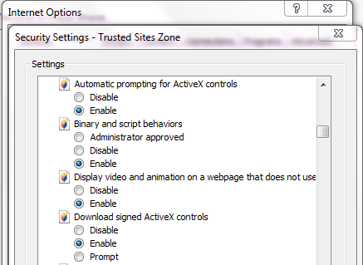

* 1. Download unsigned ActiveX controls : Enable
  2. Initialize and script ActiveX controls not marked as safe.... : Enable
  3. Only allow approved domains to use ActiveX without... : Disable

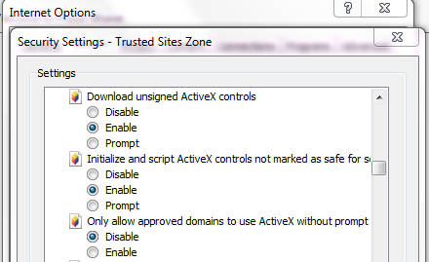

* 1. Run ActiveX controls and plug-in : Enable
  2. Run antimalware software on ActiveX controls : Disable
  3. Script ActiveX controls marked safe for scripting* : Prompt

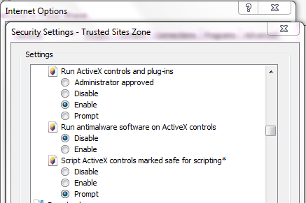

* 1. Use Pop-up Blocker : Disable



1. Do not make any changes accept above mentioned changes and Click Ok to save.
2. Click on Apply and then Ok to save settings.

**Setting for Java**

After installing Java 7 Update 51 user has to make following setting on Java:

1. Go to control panel.

2. Open Java from control panel. (If you are unable to view please make sure you have installed java and view of control panel is Small icons)

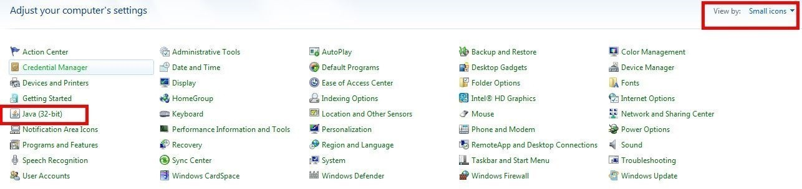

3. In General tab of Java settings click on about to view Java version.

4. Go to Java tab in Java settings and Enable.

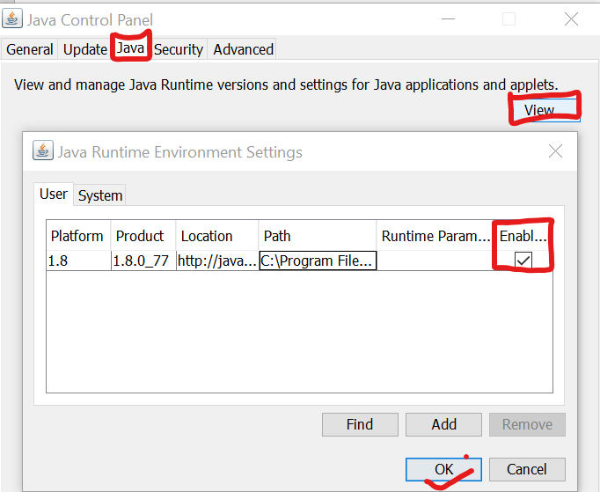

5. Go to Security tab in java settings make security level medium, Edit Site List and Add https://psb.eproc.in to the list.

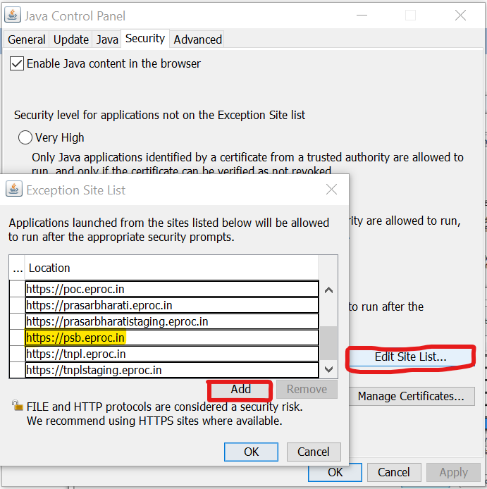

6. Go to advanced tab of Java settings: Enable Tracing, Enable Logging and Show Console.



7. Click on Place java icon in system tray



8. Now to Complete Java Settings click Apply and then Ok button.